**INTRODUCTION TO LOGIC**

**LECTURE 2**: *Deduction*

A/Professor: Mirko Farina

(m.farina@innopolis.ru)

**Systematizing Arguments**

Diagramming (or argument maps) capture the logical structure of a simple or complex argument and help assessing the strengths and weaknesses of the argument.

Diagramming helps us in assessing whether to accept an argument or not but also in generating one.

Techniques discussed in the lecture :

* Serial reasoning,
* Divergent reasoning,
* Linked reasoning,
* Convergent reasoning.

**Handout**

Deductive Validity is about the *connection* between the premises and conclusion of an argument, not their truth-values. An argument is *valid if* it is impossible for all the premises of the argument to be true, but the conclusion false

To Test Validity –> Ignore the actual truth-values of the premises and the actual truth value of the conclusion. Logicians study validity, so they study the relations between propositions. Examples:

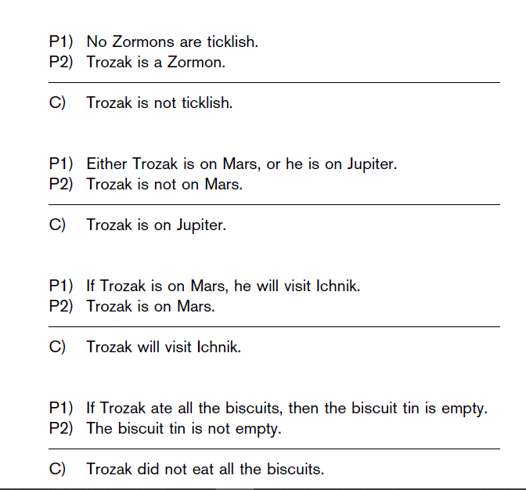

Important difference: conditionals (if-then form of declarative sentence) differ from arguments (set of premises providing good reason to believe something). Example: If it is raining, then the barometric pressure is low (conditional, not an argument). However, conditionals can be expressed in other forms too (e.g. with only, either, unless etc.)

Standard form for a conditional = Antecedent → Consequent

Arguments can be made of conditionals (Labour example slides) –> chain of conditionals, like a row of dominoes, which lead to the conclusion.

**Soundness**

Knowing that the argument is valid is not enough to show that the conclusion is true. To establish soundness we must determine the truth-values of the premises. This step requires knowledge

The argument is deductively sound, if it is valid and all its premises are (actually) true.

**Syllogism** = deductive argument that contains exactly two premises.

*Disjunctive syllogism* *(valid)*, form:

P or Q

Not P

Therefore, Q

*OR*

P or Q

Not Q

Therefore, P

*Disjunctive syllogism (invalid)*, form:

P or Q

P

Therefore, not Q

*OR*

P or Q

Q

Therefore, not P

Other valid syllogisms

*Modus Ponens*, form:

If P, then Q

P

Therefore, Q

*Modus Tollens*. form:

If P, then Q

Not Q

Therefore, not P

Others invalid syllogism

*Fallacy of denying the antecedent*, form:

If P, then Q

Not P

Therefore not Q

*Affirming the consequent* , form:

If P, then Q

Q

Therefore, P



   
   
 ***EMAIL ME!***

[m.farina@innopolis.ru](mailto:m.farina@innopolis.ru)